Objectives:

* Databases and GUI design

There is one project worth 100%

Project (create a GUI design that will extract the following table below), you will have to first design the table below using net beans derby. You can use the J Table or console to extract the data using java.

Print screen the running application with code below here, be sure to print screen the data from table after executing the Java application.

B

Included all the necessary packages and libraries yet still doesn’t run

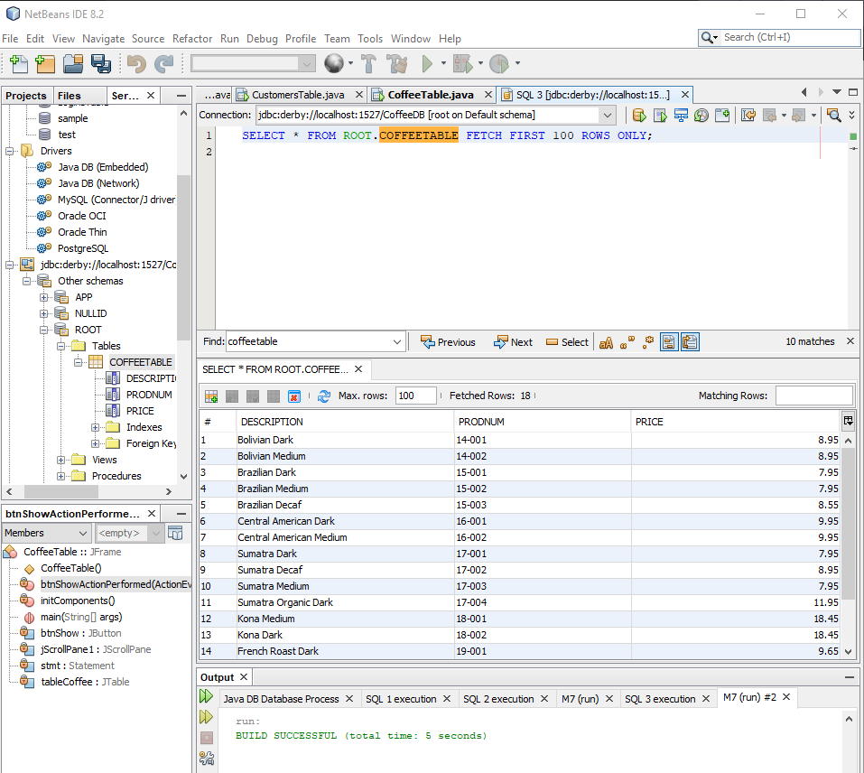

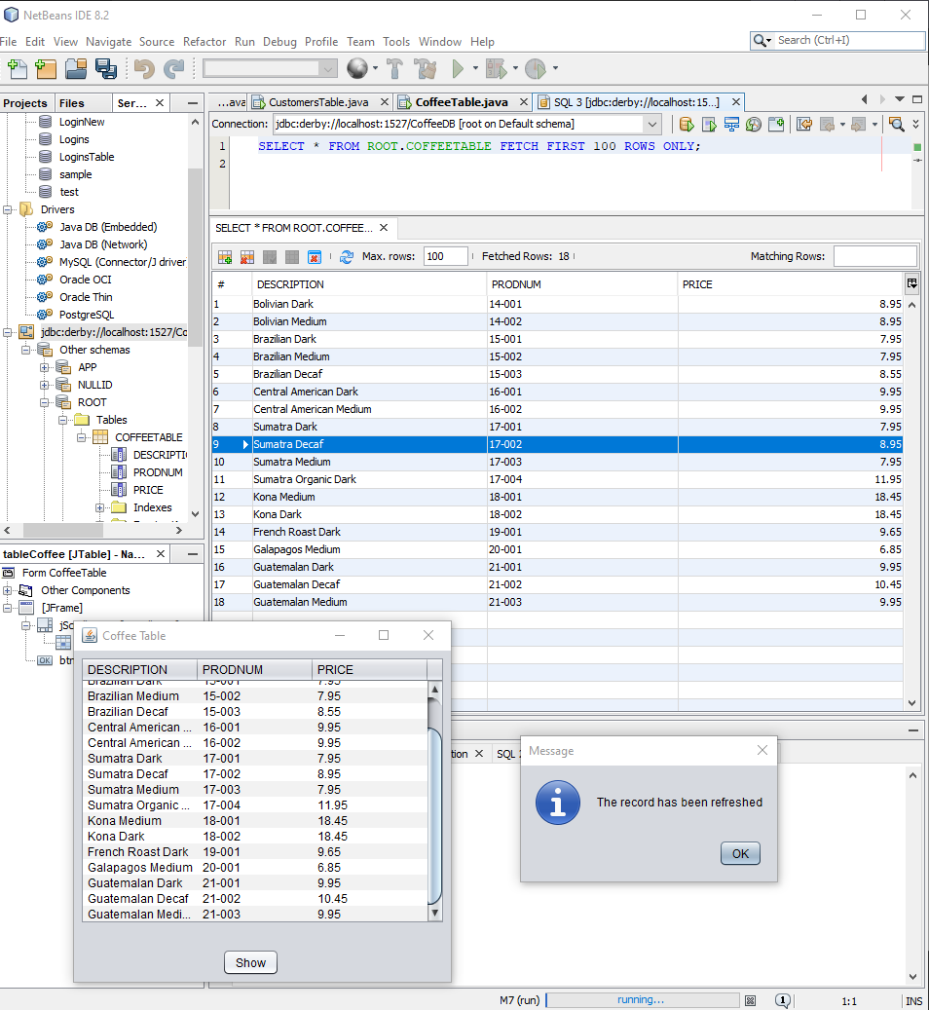

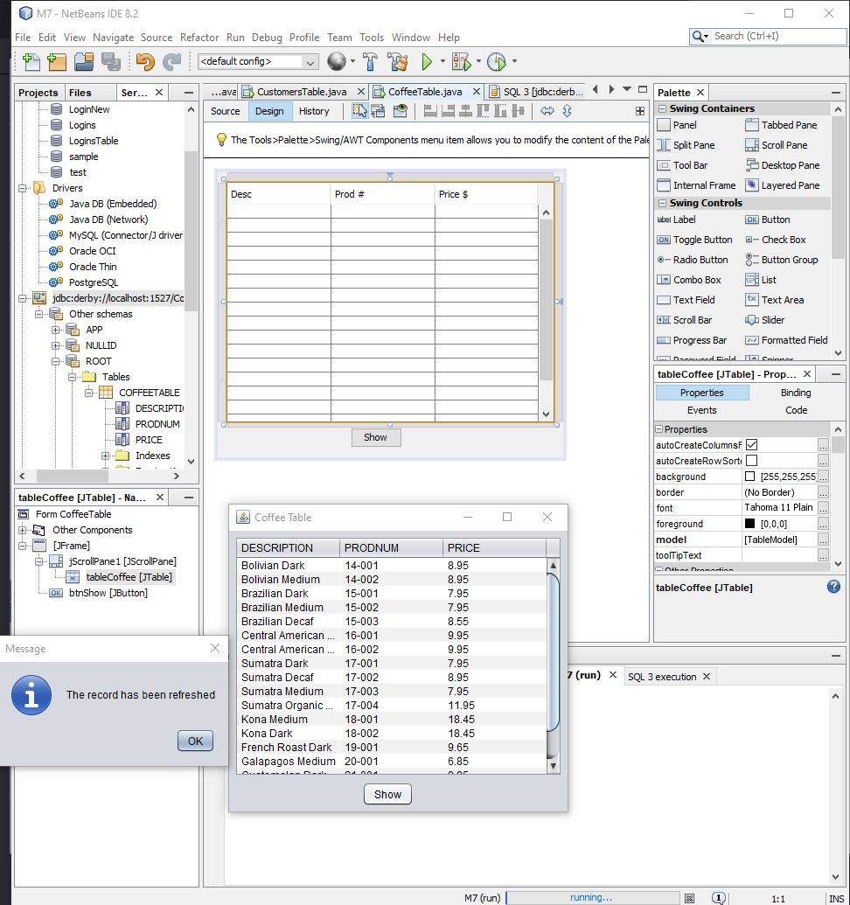

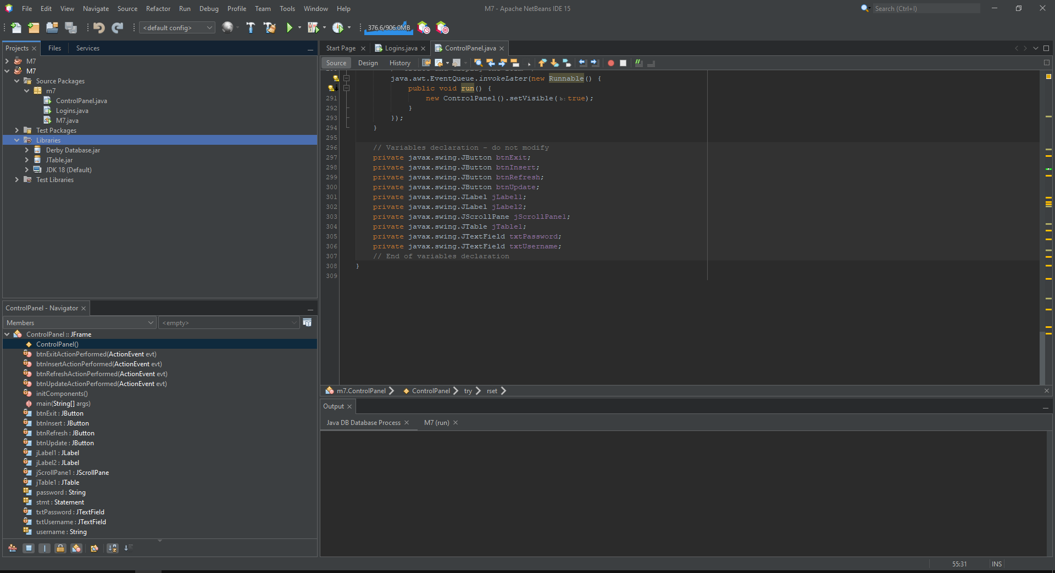

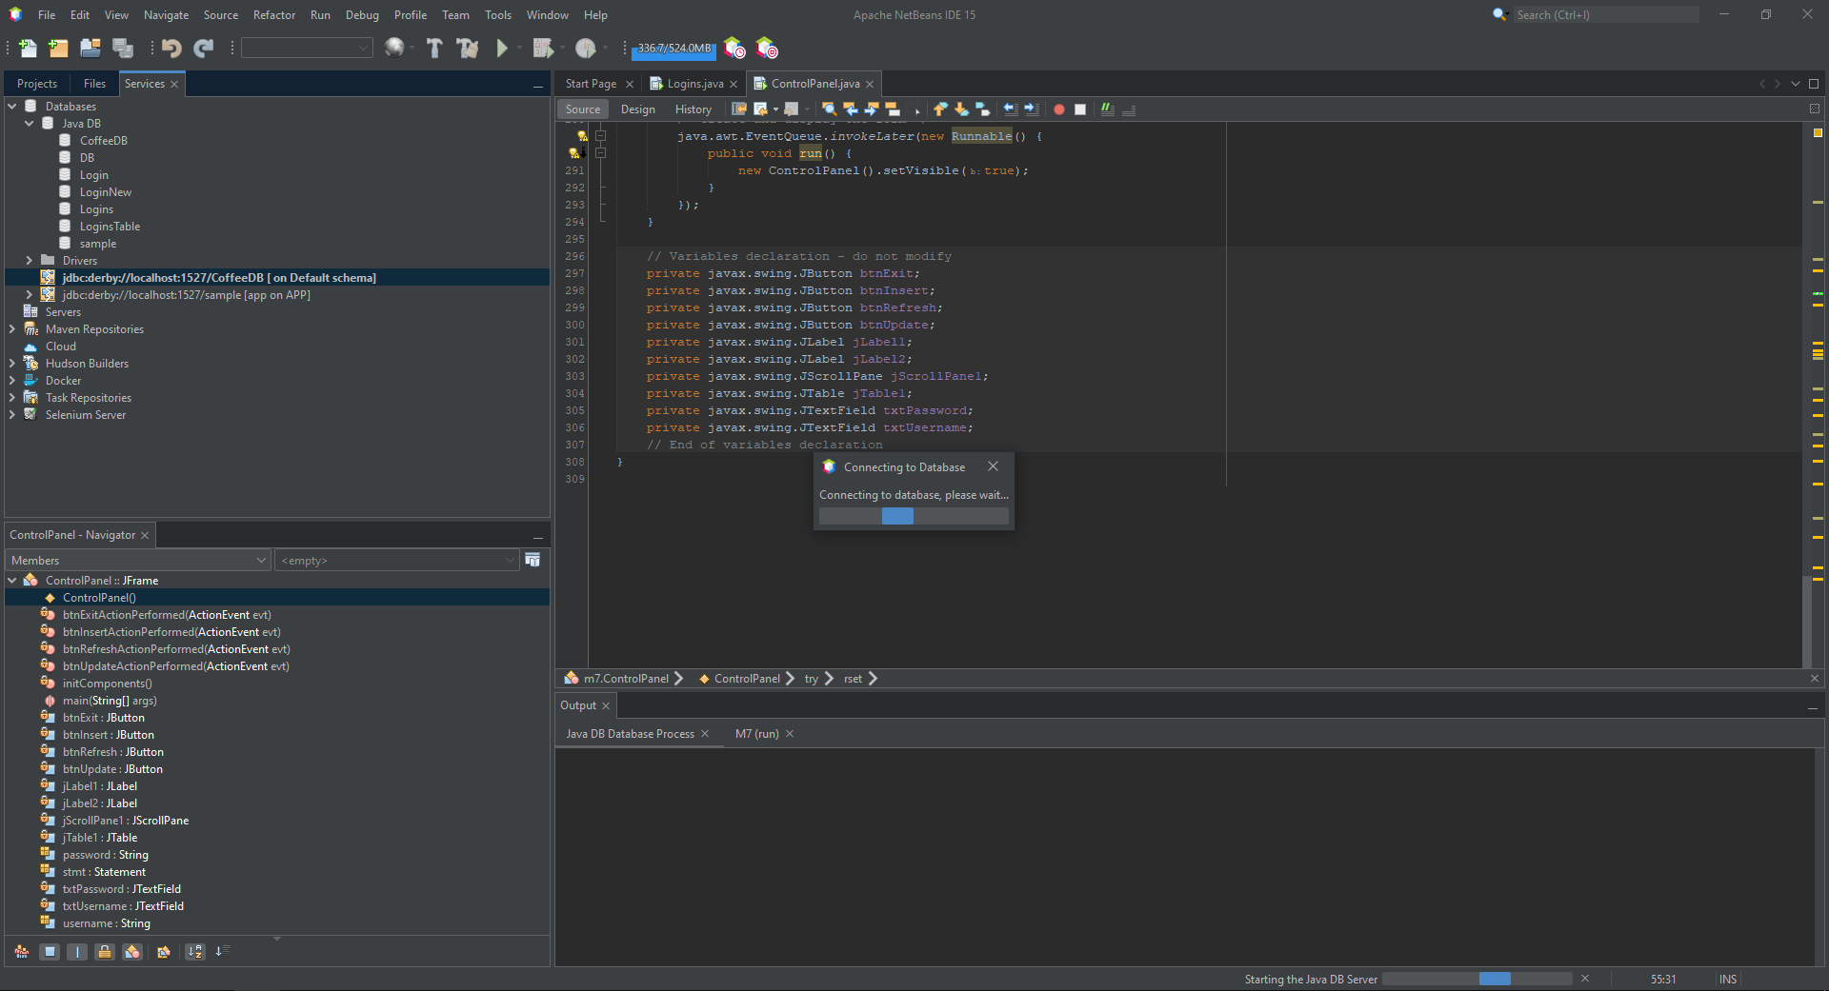

Testing out creating a new database with the correct directory

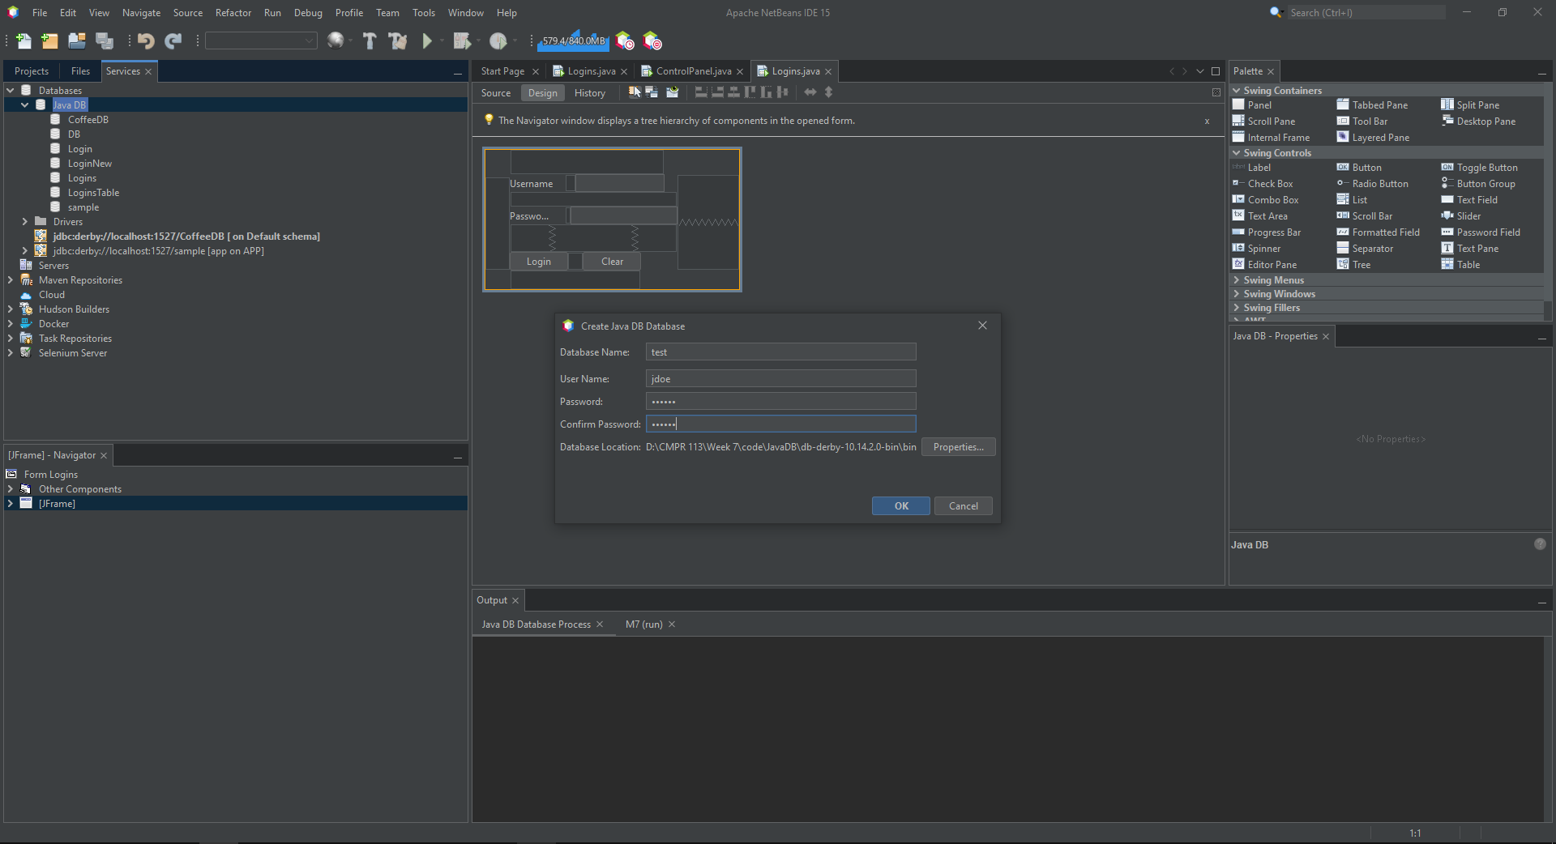

Testing out creating a new sample database

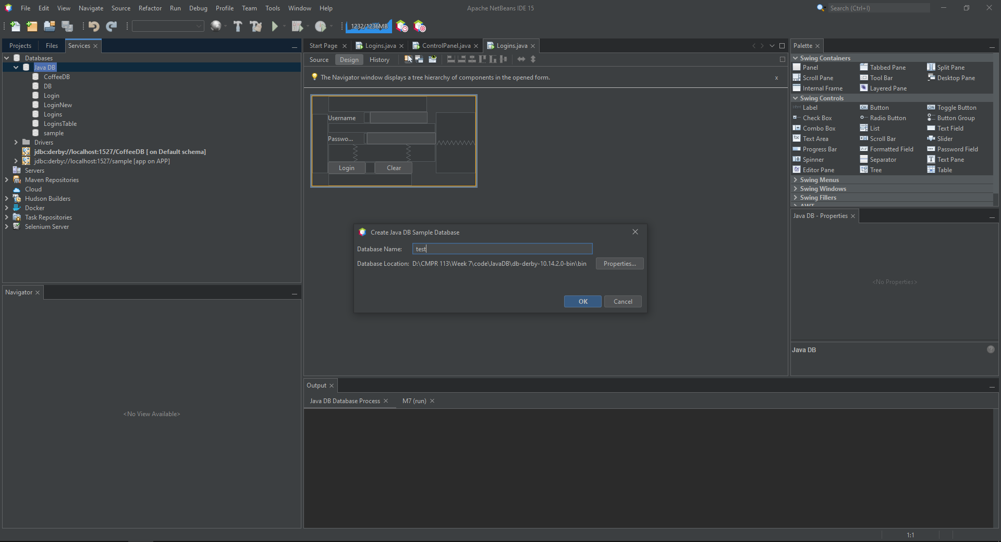

Same issues

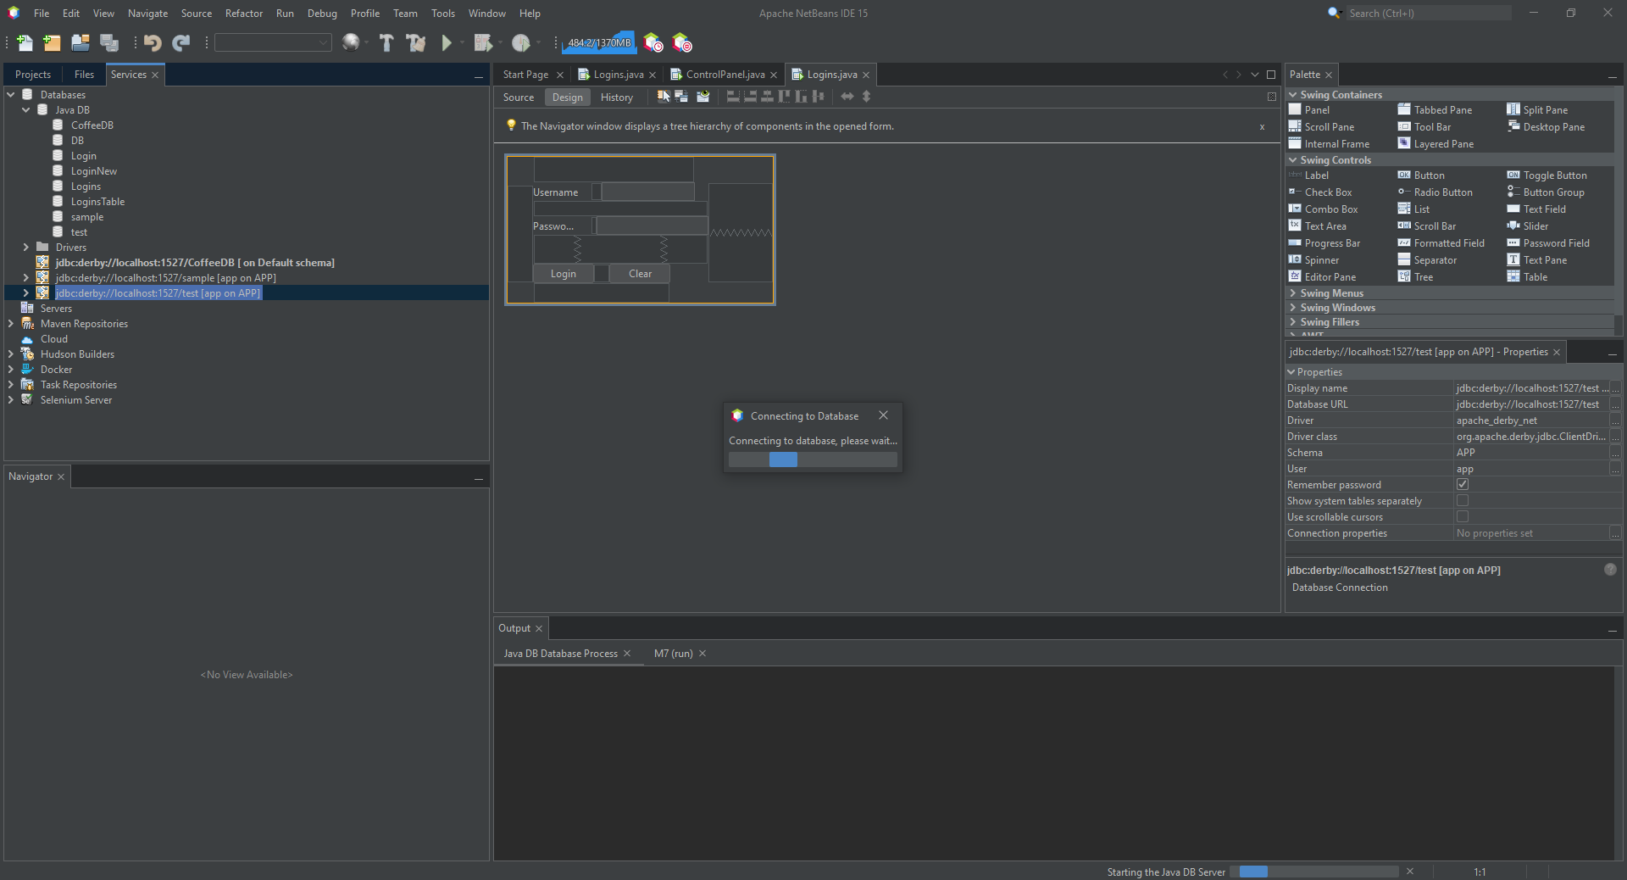

Unable to expand drivers to add data table CoffeeDB data

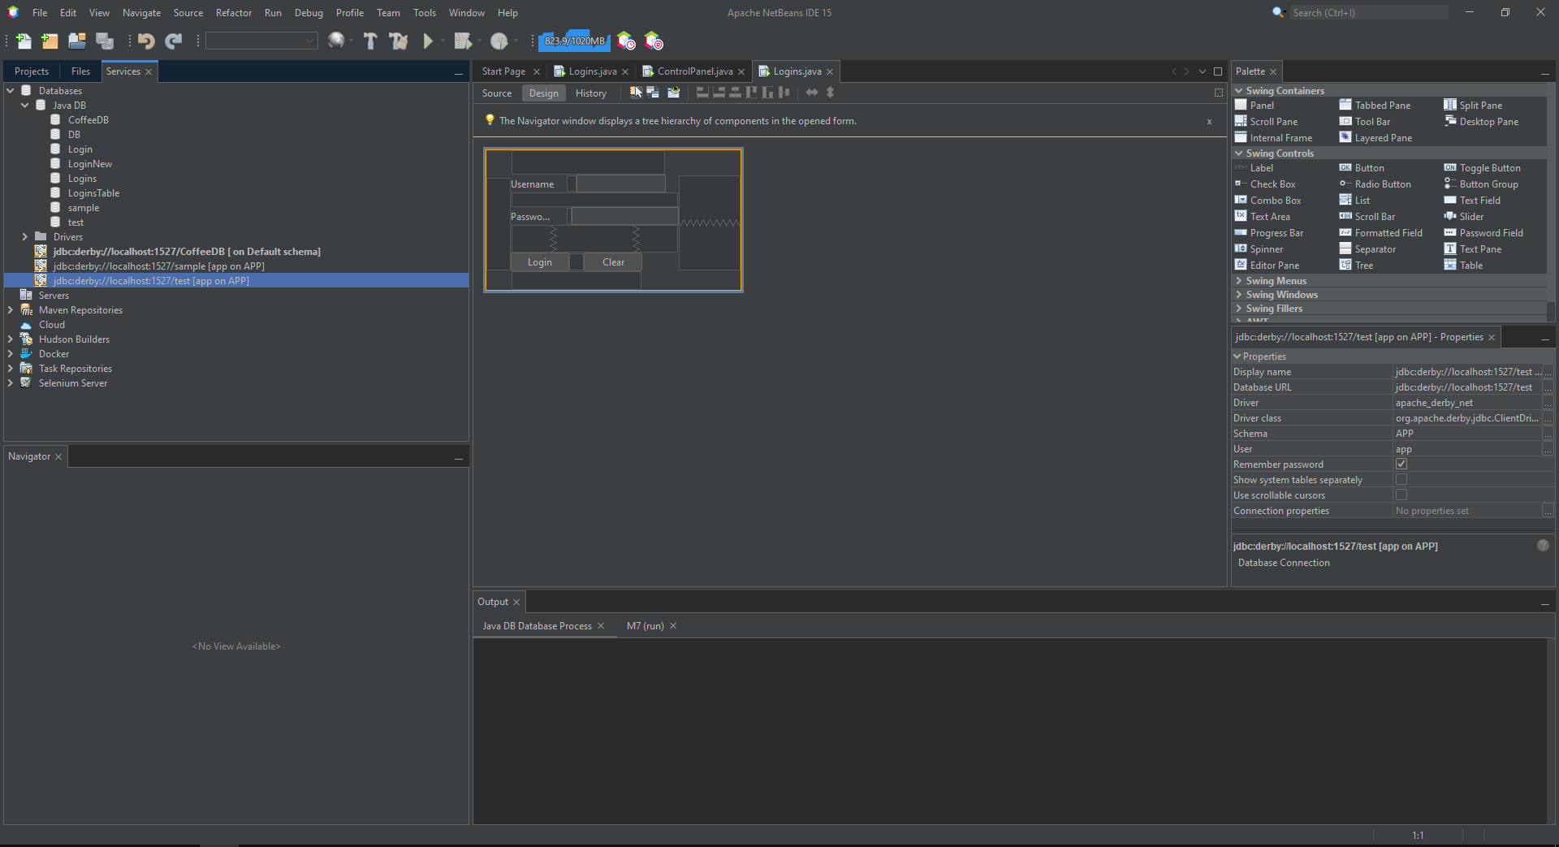

I have done all the troubleshooting I could think of including looking up my issues and messaging the wise Professor Sim requesting for assistance.

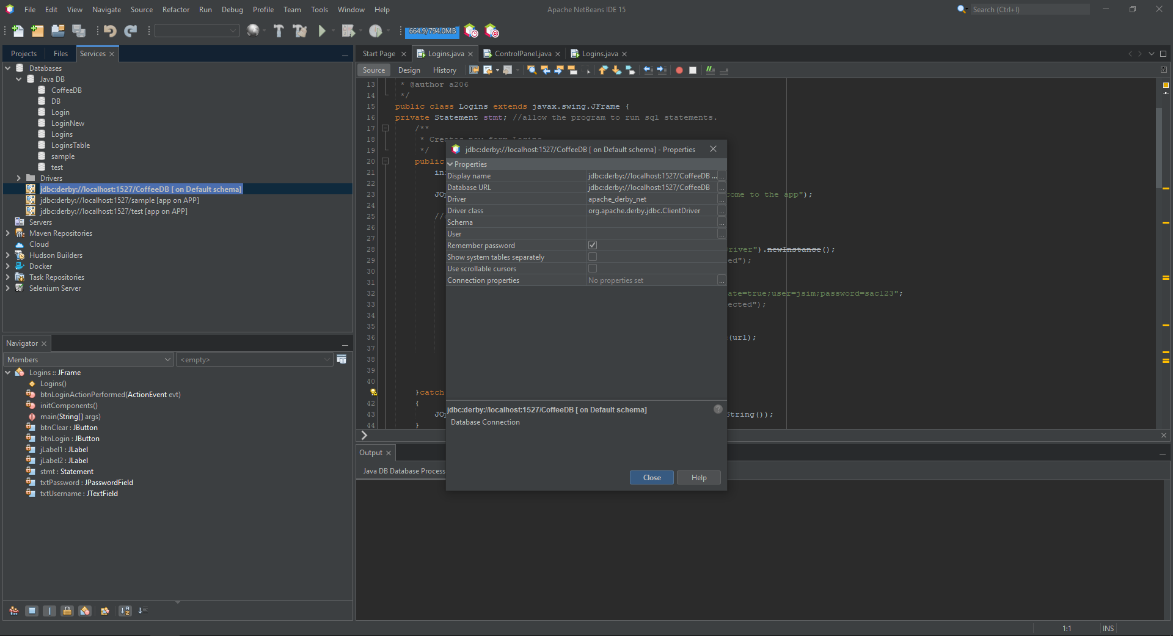

Submit this document to Module 7 homework